10910EECS204001  
Data Structures Homework 6

Due date: 2021/1/18 23:59

Submit to OJ: #13088

Upload code to iLMS

Submission

* Please **1)** submit your code to OJ (OJ: #13088),   
  and **2)** upload the zipped file (source codes) to iLMs.   
  **Both should be done before the due date.**
* Scores will be given based on your OJ results, and the uploaded file (the source codes) should be identical to those submitted to OJ. TAs will examine your uploaded codes.

Description

In this homework, you are asked to solve problems related to the minimum

diameter spanning tree (MDST).

There are 5 operations.

1. Add

2. Delete

3. AC

4. Diameter

5. SOSPD

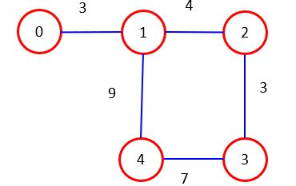

Fig. 1

Add

**Add v1 v2 w**

Add an edge between **v1** and **v2** and the weight is **w**.

p.s. **v1** is not always smaller than **v2**.

If there already exists and edge, update to the new one.

(delete the original one and add the new edge)

For example: Add 0 1 10

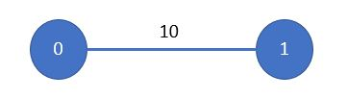

Fig. 2

Delete

**Delete v1 v2**

Delete the edge between **v1** and **v2**.

p.s. **v1** is not always smaller than **v2**.

For example: Delete 0 1

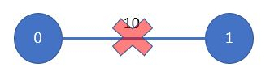

Fig. 3

AC

Output the absolute center.

Case1: absolute center is on a vertex.

Output the index of the vertex.

If there are many absolute centers on vertices, output the one with the

smallest index.

Case2: absolute center is on an edge(i, j), and i < j.

Output i j

If there are many absolute centers on edges, output the first one in

lexicographical order.

Lexicographical order: $(a, b)≤(a', b') ⇔ a<a' or (a=a' and b≤b')$

Case3: If there are many absolute centers on both vertices and edges, output

the vertex with the smallest index.

If the graph is not connected, output “Not connected graph”.

For example, in Fig 1, the output will be:1 4

Diameter

Output the diameter of minimum diameter spanning tree.

If the graph is not connected, output “Not connected graph”.

For example, in Fig 1, the output will be: 16

SOSPD

Output the sum of shortest path distances from absolute center **c** to **v $∈V$**

If the graph is not connected, output “Not connected graph”.

For example, in Fig 1, the output will be: 26

Note

There are only **Add**、**Delete**、**AC** operations in testcase 1**.**

There are only **Add**、**Delete**、**Diameter** operations in testcase 2**.**

There are only **Add**、**Delete**、**SOSPD** operations in testcase 3**.**

And testcase 4,5,6 would have all operations.

You are allowed to use STL.

Input

A testcase begins with an integer **n**, representing the number of vertices.

After the first line, the following lines are operations.

Please note:

1) $1≤the number of vertices≤ 100$

2) $1≤weight ≤ 100$

(weight is integer)

3) $the diameter of MDST≤ 1000$

4) $SOSPD≤ 10000$

Output

According to the operations, and each output is separated by a newline symbol.

Sample input

5

Add 0 1 3

Add 1 2 4

Add 1 4 9

Add 2 3 3

Add 3 4 7

AC

Diameter

SOSPD

Delete 0 1

AC

Sample output

1 4

16

26

Not connected graph